20) Design a wireframe in Figma for a mobile application showcasing power management approaches.

Aim:
Design a wireframe in Figma for a mobile application showcasing power management approaches.

Procedure:

- Create a file
- Add The First Frame
- Add Shapes
- Add Text
- Create The Second Frame
- Add Prototyping
Step By Step Procedure :

Interface Of Experiment

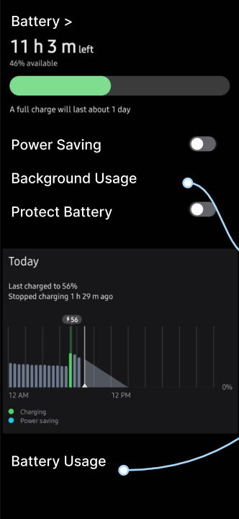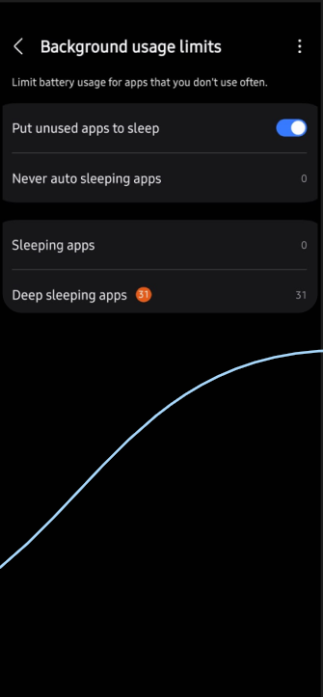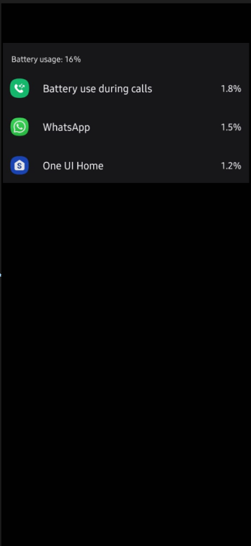

Prototype: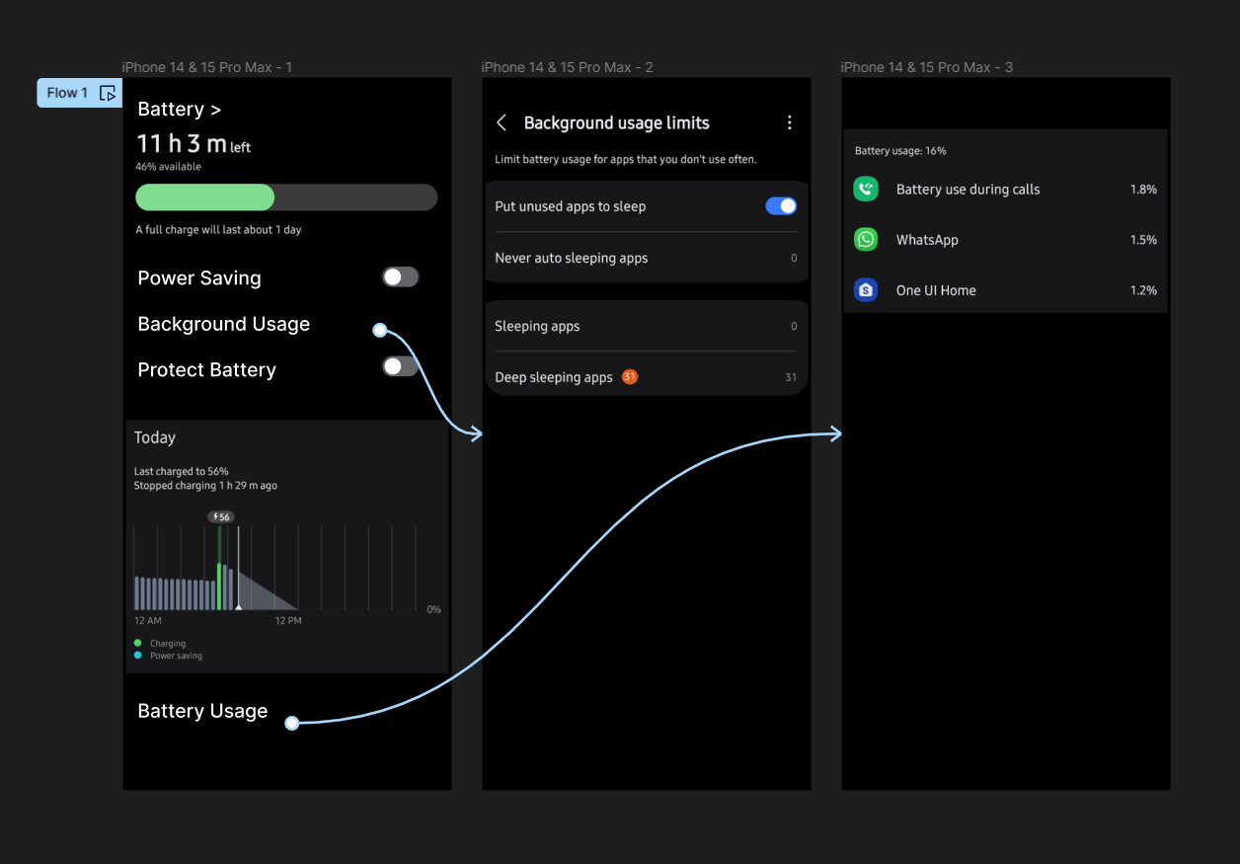

Result:
Hence the mobile application showcasing power management is created and executed successfully.

